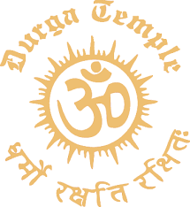  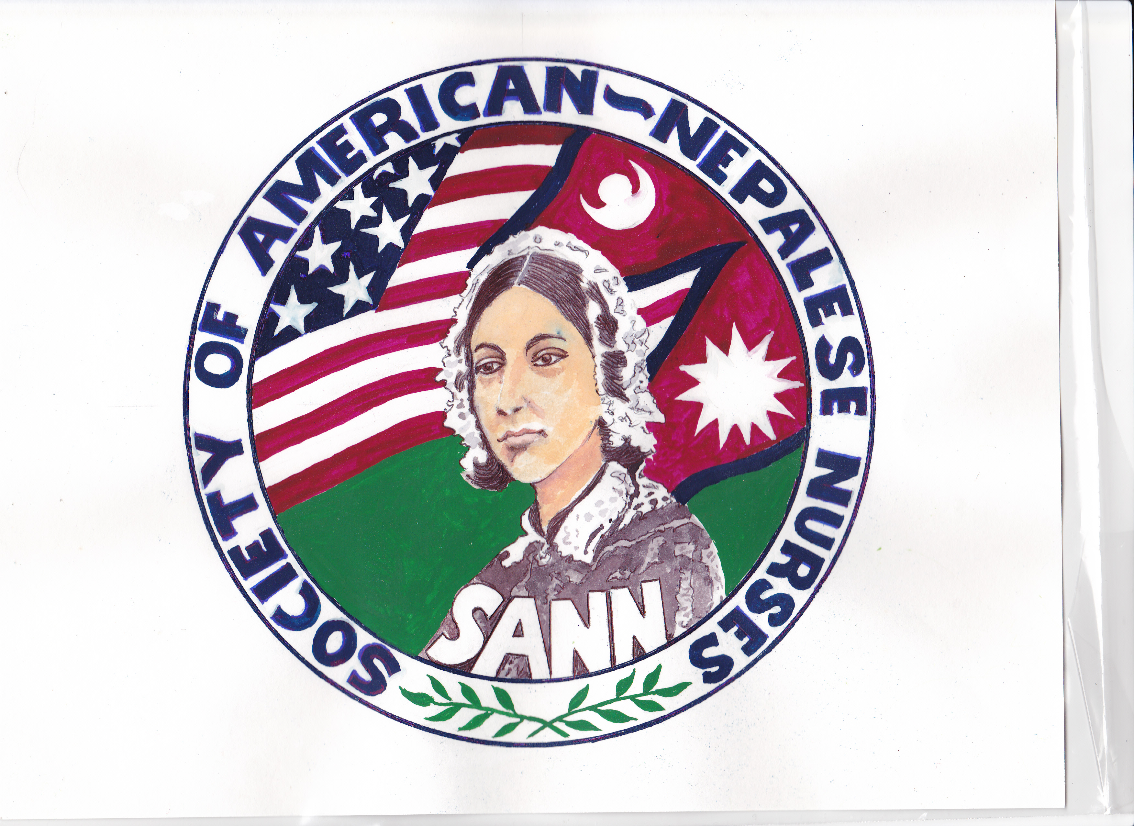  Sunday, May 8, 2022. 9 AM TO 2 PM  health fair  In collaboration between SANN & Durga Temple  Contact persons:  Manju Sangraula, Indira Shrestha  Sumitra Aryal, Januka Shrestha  Bimu Risal, Bandana Luitel  Dhana Pangeni, Urmila Devkota Ranjana Dahal, Ranjana Tiwari Rubina Prajapati, Sangita Bajgain Sujana Dhakal, Shanta Paudel Shova Adhikari, Subi Siwakoti Shanti Bhatta, Suzana Khanal Suman Sangraula, Laxmi Sharma Laxmi Pandey, Jotsna Pudasaini Maya Baral, Monica Mali Namrata Paudel, Sharmila Paudel Ranjana Tiwari, Hari Ghimire Menisha KC, Mira Prasai Arya Chapagai, Netra Neupane Sanjana Tamrakar, Radhika Khadka, Tika Kandel Sanjana Tamrakar | ABI (to check how well blood is flowing)  Blood Test (cholesterol and fasting blood sugar: $10.00, report in 5 minutes)  Colon Cancer Screening  Dental Evaluation  Doctor Check-ups  Blood Donation Drive  CPR & First-aid  Chair Yoga Meditation  Stress management  Hearing & Vision checks  Health Education  Info Booth by Fairfax County  SANN’s partnership info  Location  8400 Durga Place, Fairfax Station, VA 22039  Call 1-888-370-SANN (7266)  Durga Temple:703-690-9355

