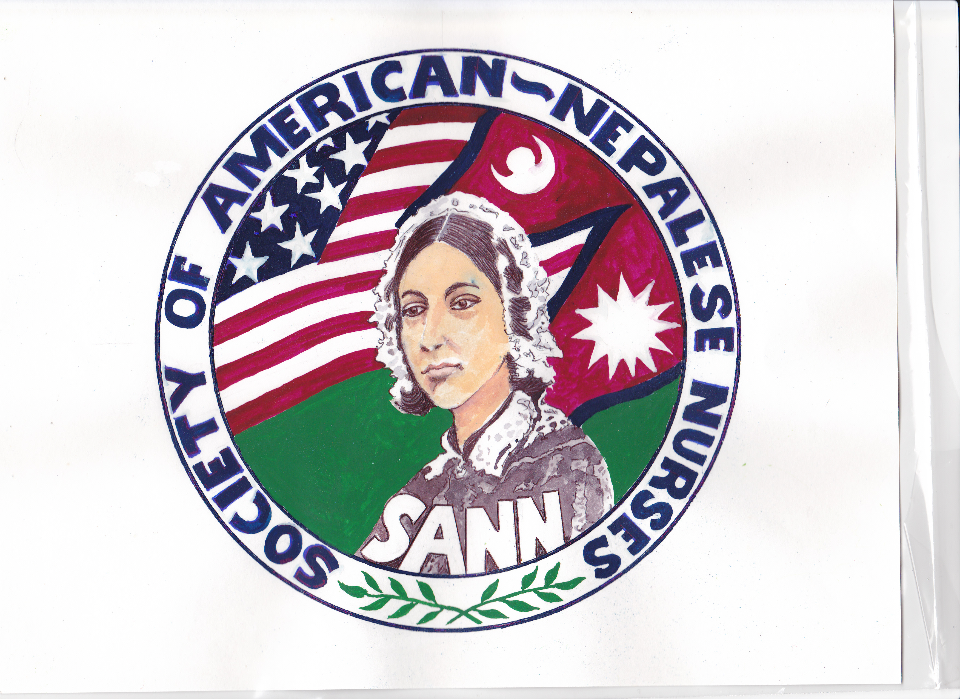 |  | 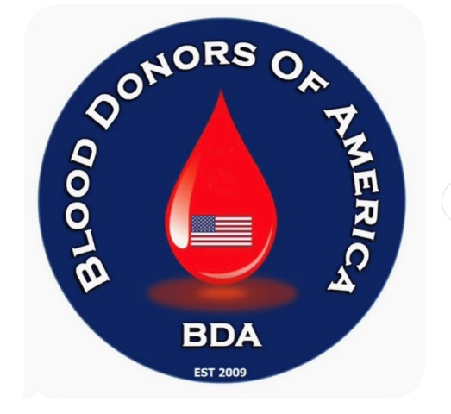

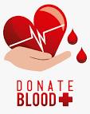
Blood Drive to save lives

Please eat and sleep well, stay hydrated and bring your ID for donation
Sunday, May 8, 2022, from
10:00 am to 2:00 pm
Venue: 8400 Durga Place, Fairfax Station, Virginia
For more info: 1-888-370-7266 (SANN), www.sannnurses.org

